**Pooch**

**User Manual**

**Code Release 7.0**

**April 22, 2019**

**Introduction**

Welcome to Pooch! The dog-focused petcare web app with plans to become an all-in-one service for everything pet-related. Our users are dog owners, people who want to adopt dogs, and dog service providers. You can view our web application [here](https://cecs-491-1934c.web.app/).

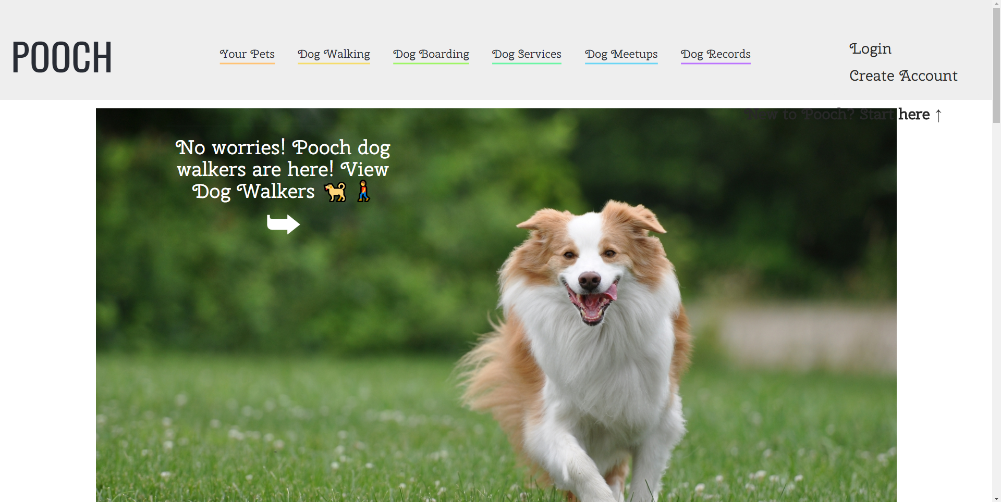

**New Users / Create Account**

1. The website is hosted online using Firebase.
2. The way users can access our web application is through the link provided in the slides and user feedback.
3. The ways to sign in as a NEW USER for our application is either:
   1. Click on “Create Account” on the right of the navigation bar.
      1. Type in your valid email address, a suitable password and confirm the password that you previously mentioned to enjoy the features.
         1. You can go back to the login page if you wish to login with a different method.
         2. Click on “Create Account” in the center of the screen.
   2. Sign in using the Google API (an additional feature our application provides)
      1. You can go back to the login page if you wish to login with a different method.
      2. Click on “Create Account” in the center of the screen.
4. Either way, the user signs in, it takes the user to the owner profile page.

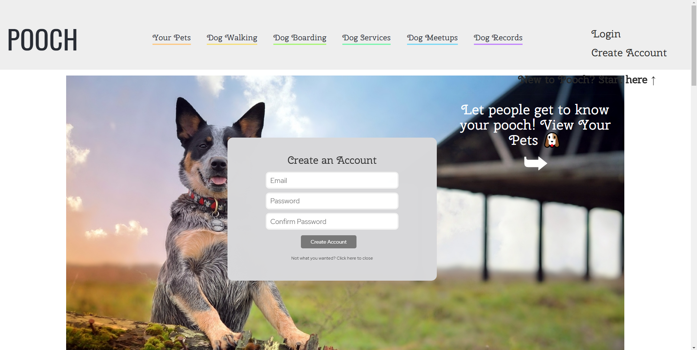

**Logging In**

1. Existing users type in the correct URL.
2. The ways to log in as a registered USER for our application is either:
   1. Log-in directly -
      1. Type in your registered email address and the correct password to enjoy the features.
   2. Log in using the Google API, if your account is validated and identified by Google service.
   3. Click “Login” on the right of the navigation bar.
      1. Enter your correct email and password.
      2. Click on “Login” in the center of the screen.
3. Either way, the user logs in, it takes the user to the owner profile page.   
     
   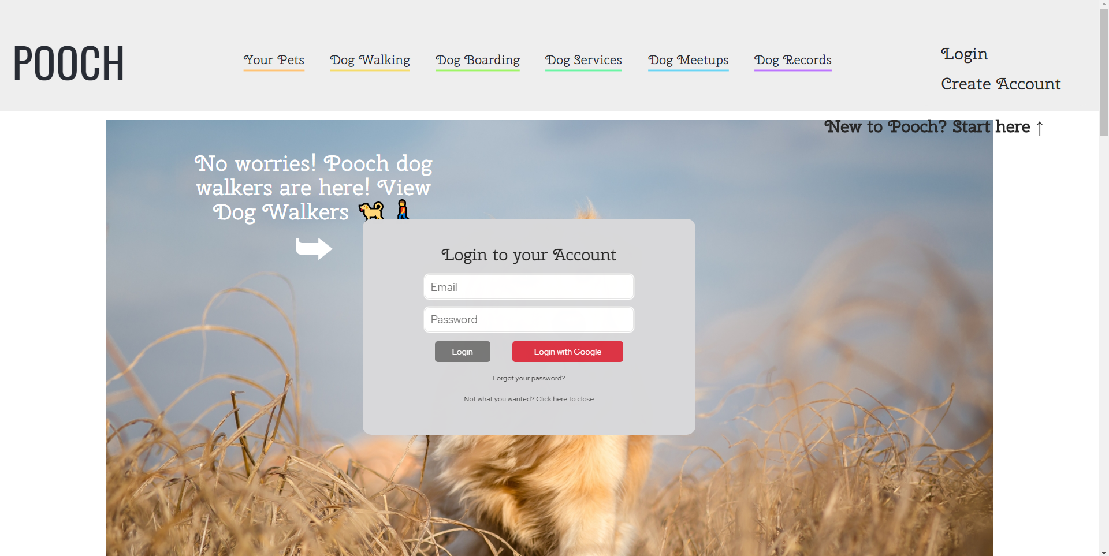

**Setting up a profile**

1. On the first login, you will be prompted to set up your profile. Click either “Dog Parent” or “Dog Service Provider”.
   1. Select a profile picture, enter your information, and then click on “Create Parent Profile”.  
       OR
   2. Click on either “Dog Walking” or “Dog Boarding”.  
       OR
   3. Select a profile picture, enter your information then press on “Create Dog Boarding Profile.  
        
      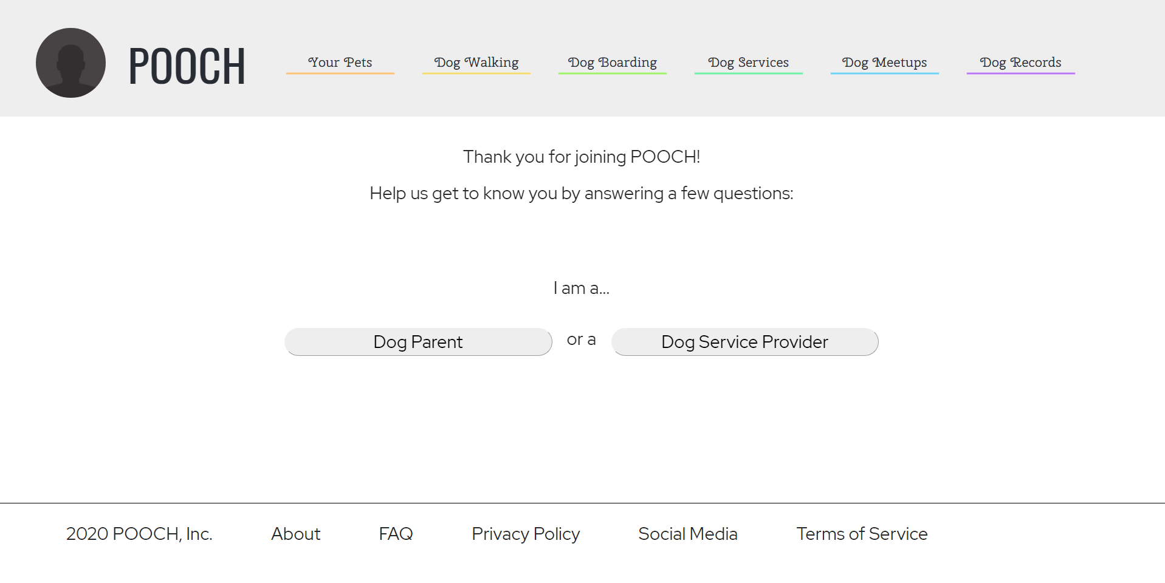

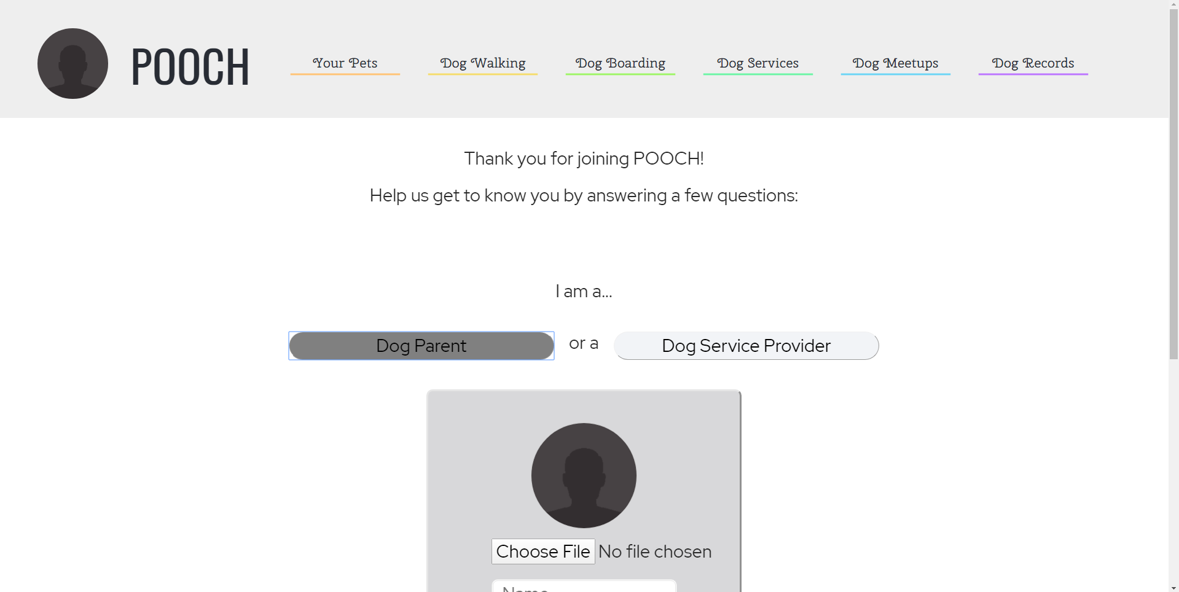

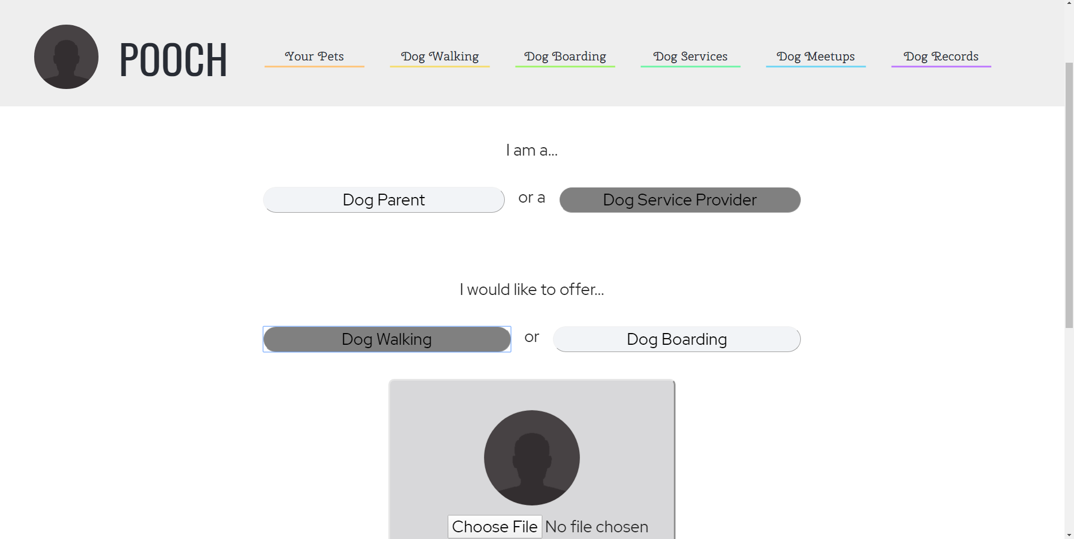

**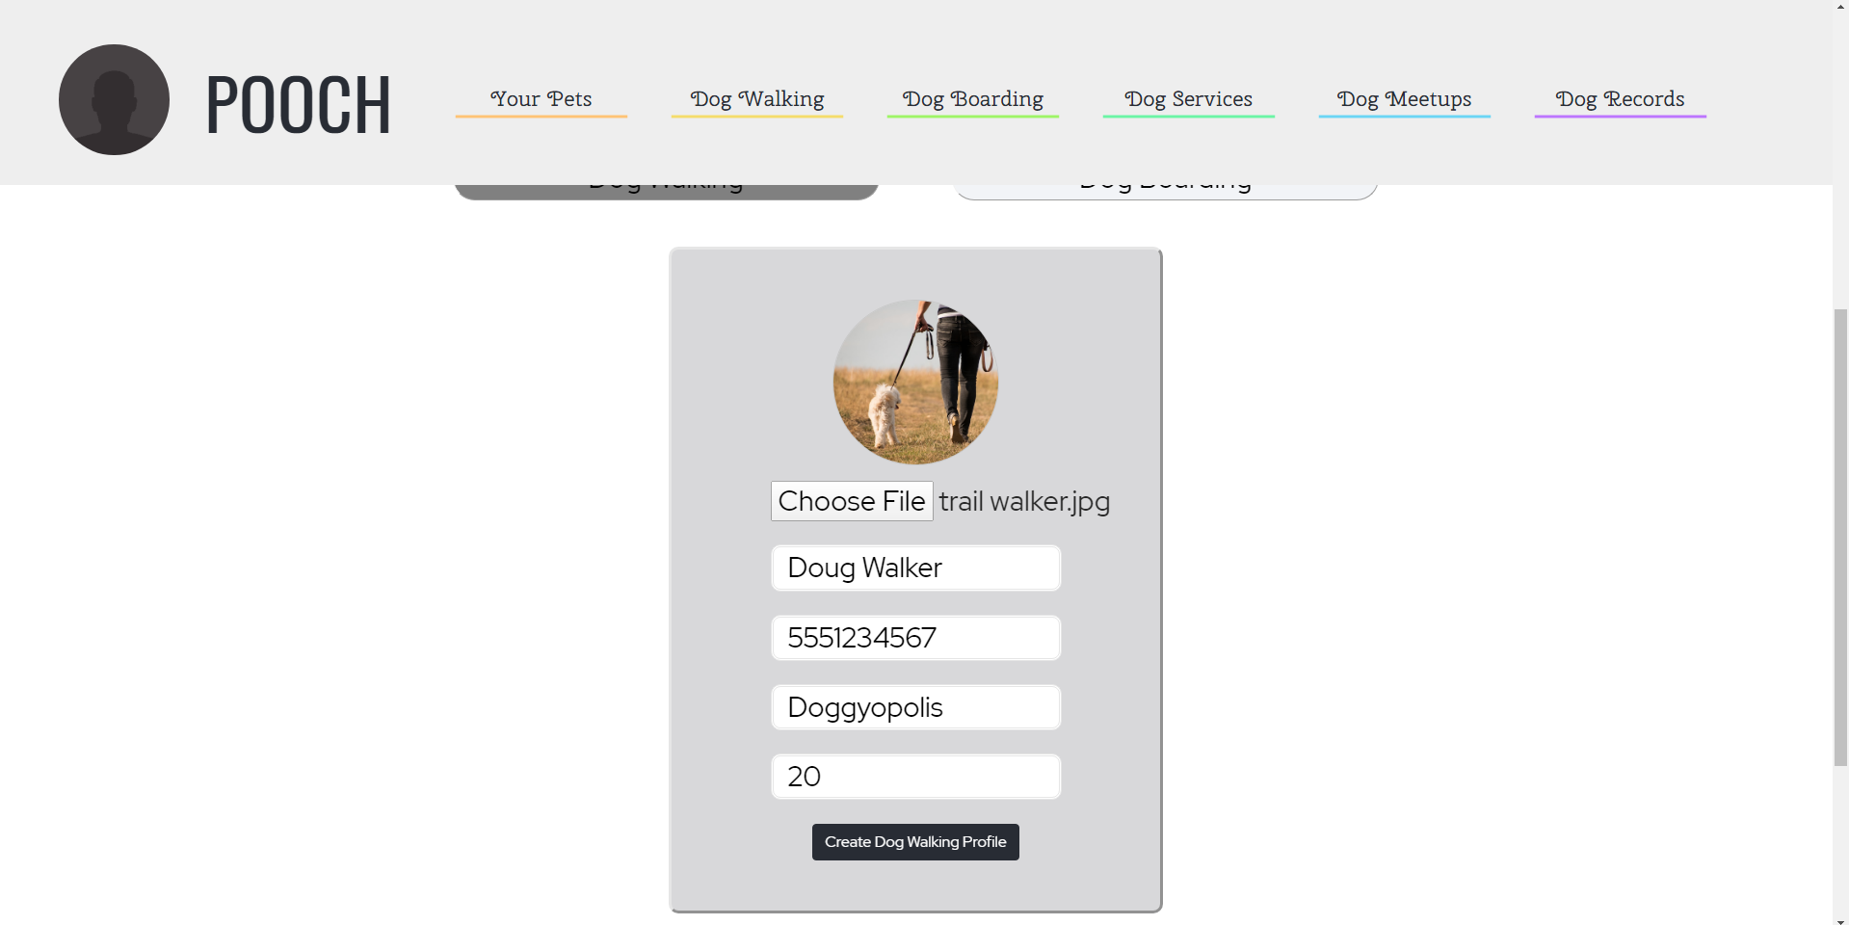  
  
Navigation**

The pages of the web app are visible in the navigation bar located at the top of the page. It has your profile picture at the left most corner to give a personalized experience to the users. The feature tabs are color-coded for more visual appeal and it is no longer monochromatic. The right of the navbar contains buttons to “Log in” and “Create Account”.



**Home Page**

This page is visible when the user logs in and can also be viewed by clicking POOCH in the navigation bar. It is the face of the website and will be feature-rich, displaying almost everything a user needs in a glance. The users can view all the features the web application has to offer, when they scroll through the whole page, on click on a particular feature on the navigation bar, to know more about a certain feature. The home page also contains a slideshow showing some feature pictures provided in the application.   
When a user is not logged in, then clicking on the navigation bar, will lead the user to the paragraph descriptions of the features. When a user is logged in, and click on the tabs of the navigation bar, then the respective click will take the user to the web page for that feature.   
  


**Your Pets**

This will allow users to view and alter details about their pets. The user can add their pet’s name, gender, breed, color, and date of birth. The “Submit” button adds this information to a table. All the fields need to be filled in order to submit the form or a pop up would be generated regarding the error in the input field. When they return to this page, all of the pets can be easily viewed alongside one another. Users will also be able to add pictures of their pets. Delete pet profiles is also an added feature, users can just click on the pet tab with their picture, then click on “Delete Dog Profile” at the bottom, which will lead to the deletion of the requested profile.  
  
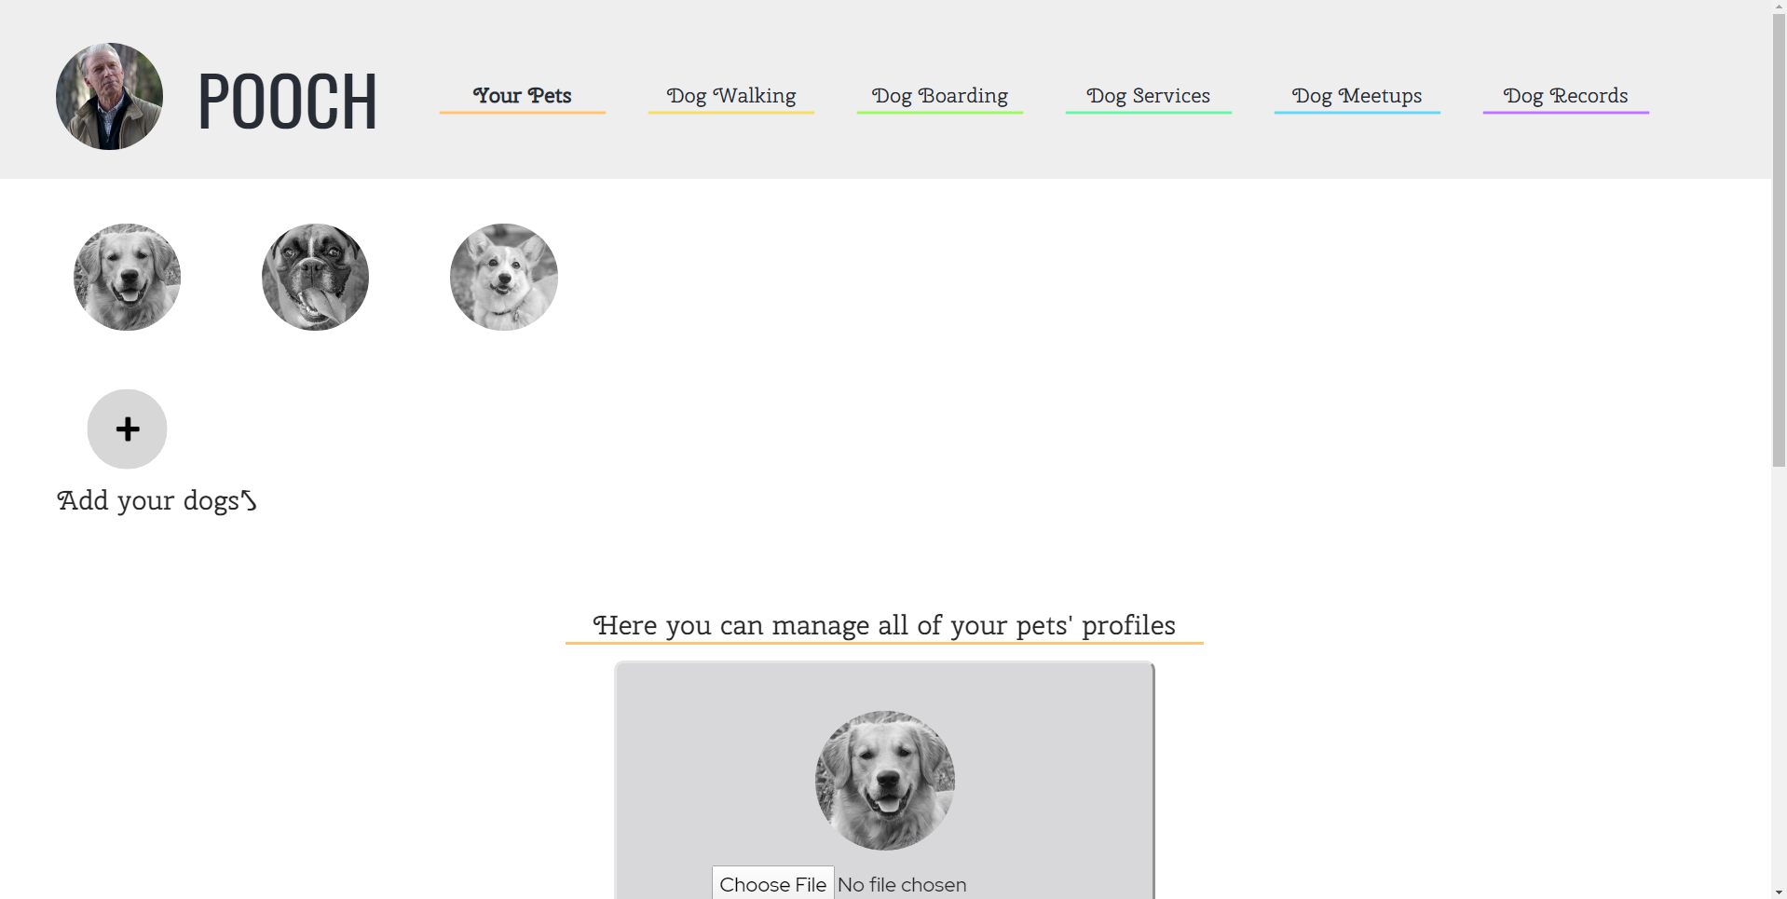

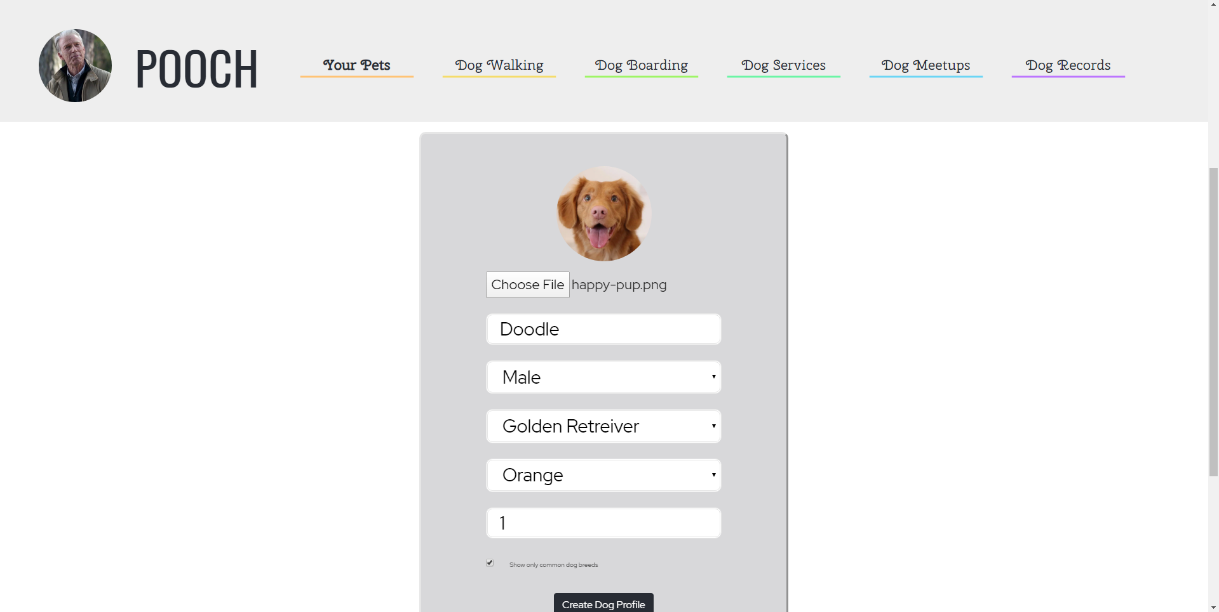  
  
  
**Deletion of Dog Profiles:**  
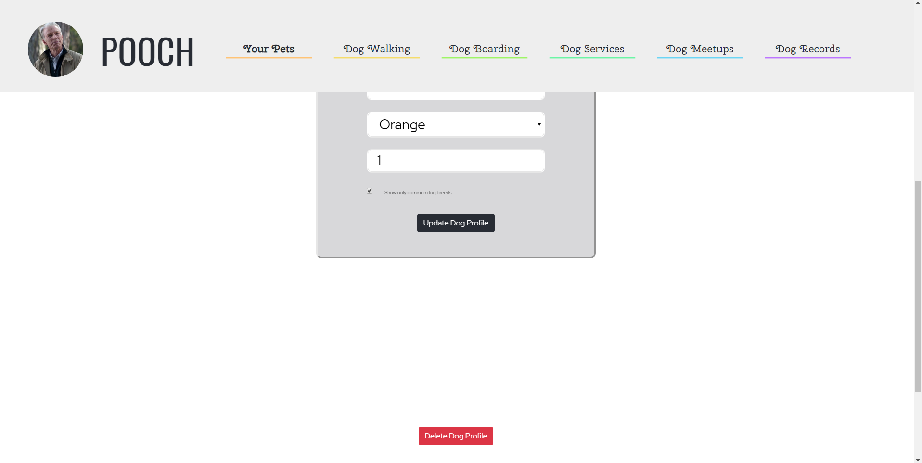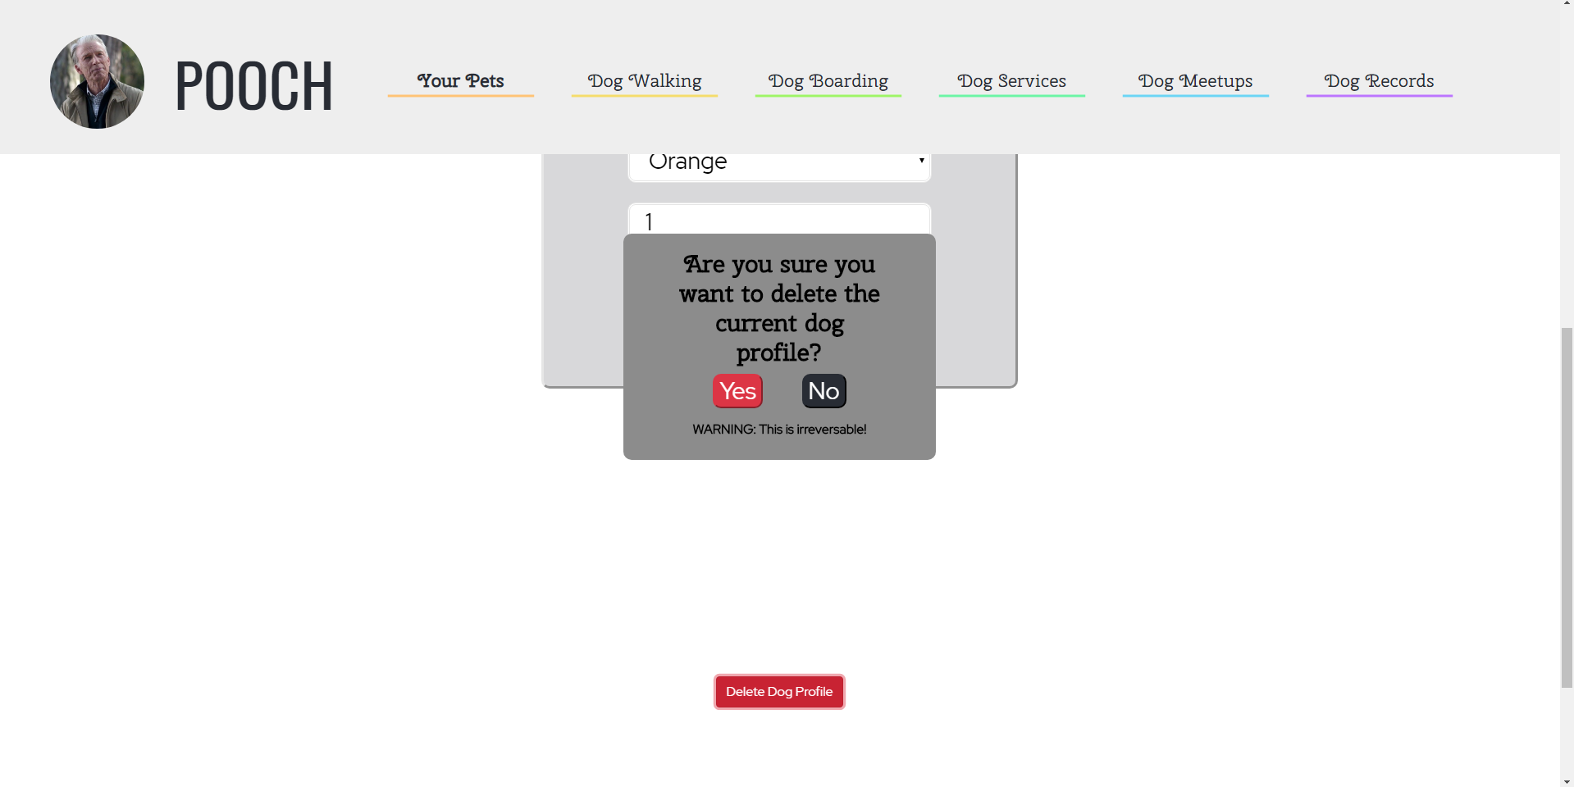

**Dog Walking**

Users can view dog walkers who have signed up through the form on the same page. All the fields need to be filled in order to submit the form while becoming a dog walker or a pop up would be generated regarding the error in the input field. Users will be able to view the profiles of individual walkers. Dog walkers will also have a rating based on the reviews left for them.

1. Users can search for respective dog walkers.
   1. Click on “Dog Walking” on the navigation bar.
   2. Click on “Search...” in the middle of the screen.
      1. Begin typing the dog walkers to be filtered, letter by letter. This search can be based on the categories listed on the right side of the search bar.  
         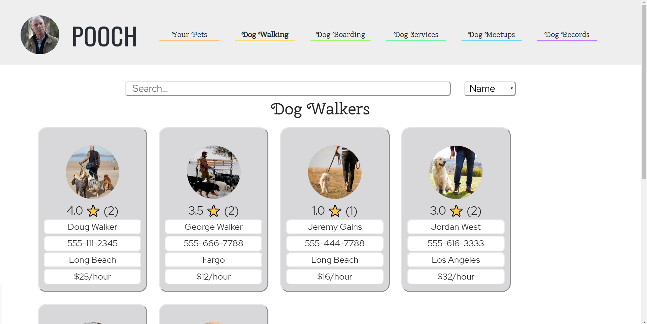
2. Users can also sort dog walkers.
   1. Click on “Dog Walking” on the navigation bar.
   2. Click on the dropdown menu that says “Name” by default.
   3. Click on “Name”, “City”, or “Hourly Rate” to order dog walkers by that attribute.  
      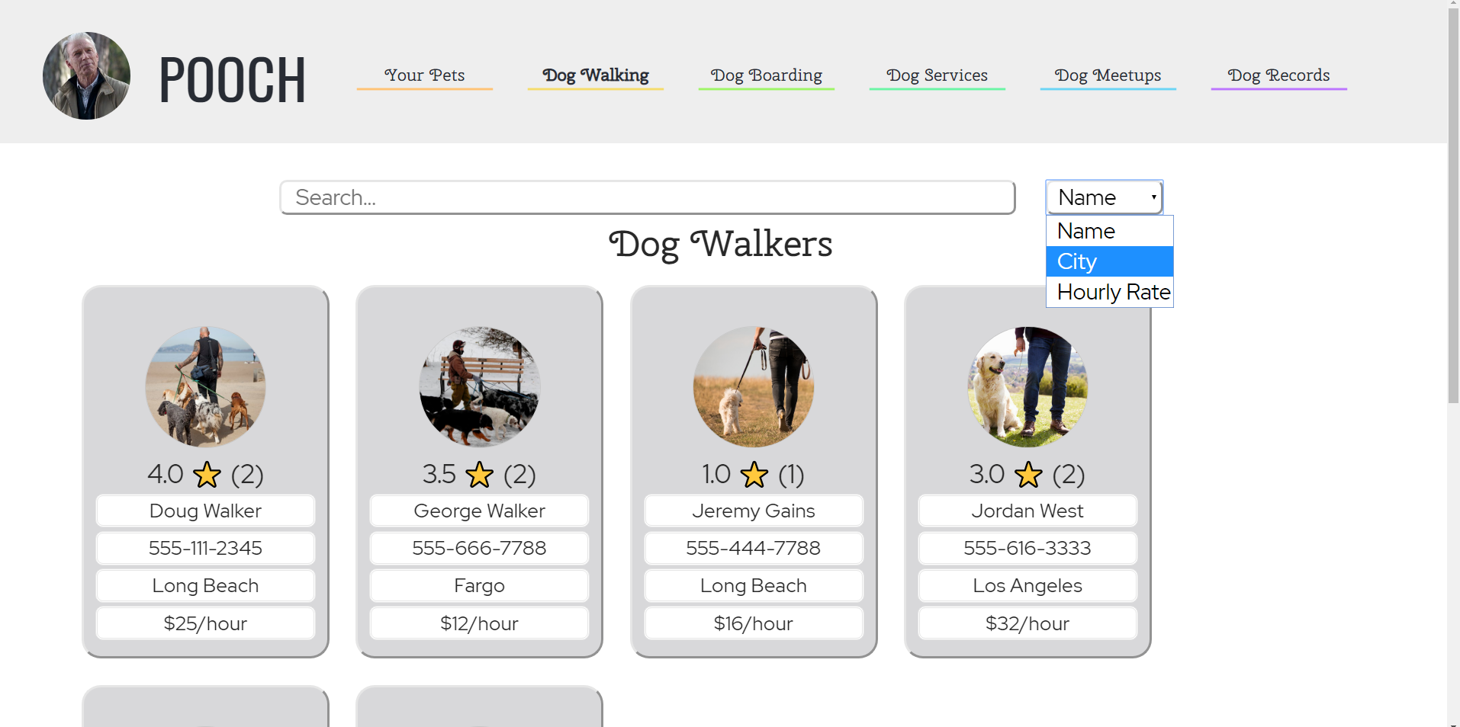
3. View Dog Walkers
   1. Click on “Dog Walking” on the navigation bar.
   2. Click on a tile, you want to view.
   3. See the dog walker’s information, average ratings and also reviews (if any).  
        
      
4. Review the dog walkers
   1. Click on “Dog Walking” on the nav bar.
   2. Click on a dog walker tile.
   3. See the walker’s information, average rating, and the reviews.
   4. When you click on a tile, the user can add a rating and also a review for a respective dog walker.   
        
      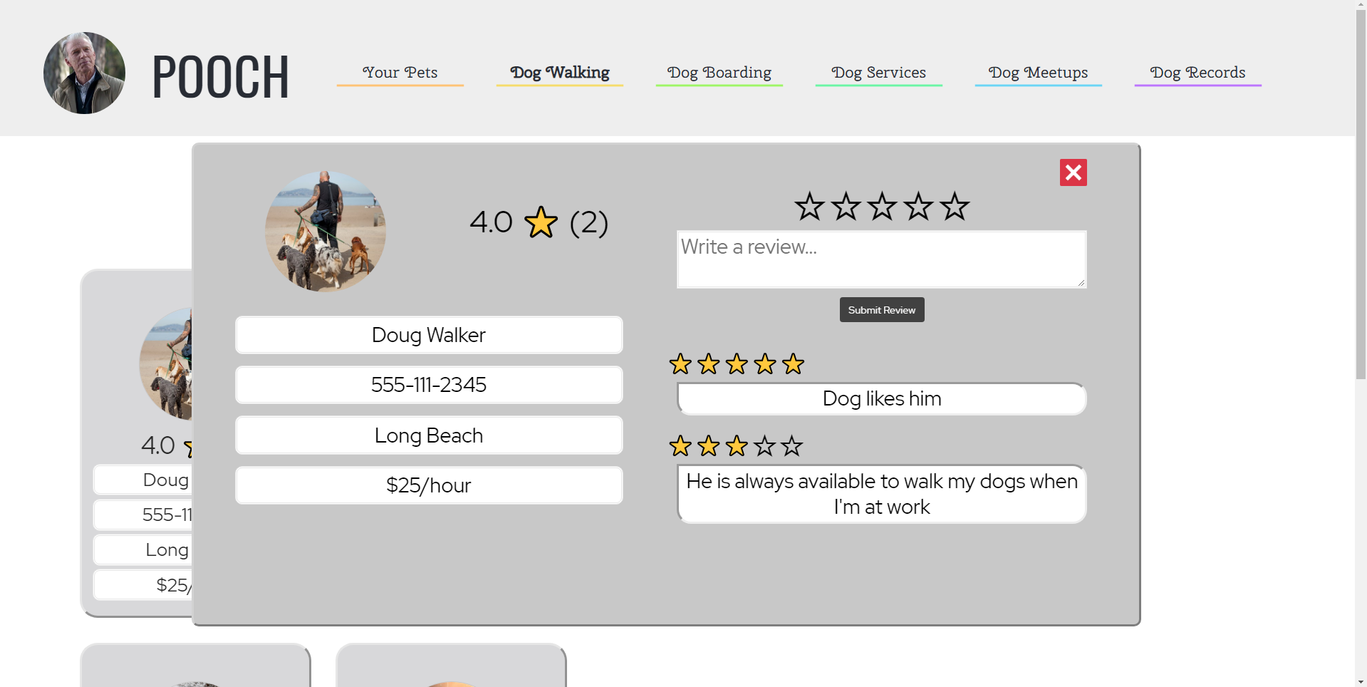

**Dog Boarding**

Users can view dog boarding companies who have signed up through the form on the same page. All the fields need to be filled in order to submit the form while becoming a dog boarder or a pop up would be generated regarding the error in the input field. In the future, the form to become a dog boarder with Pooch will be on a separate page. Dog boarders will have to upload key documents to verify their identity and address. Users will be able to view the profiles of individual dog boarders. Dog boarders will also have a rating based on reviews left for them.

1. Search Dog Boarders
   1. click on “Dog Boarding” on the navbar
   2. Click on “Search…” in the middle of the screen
   3. Begin typing for the dog boarders to be filtered, letter by letter (Note: the category to the right of the search bar determines what is being search for)

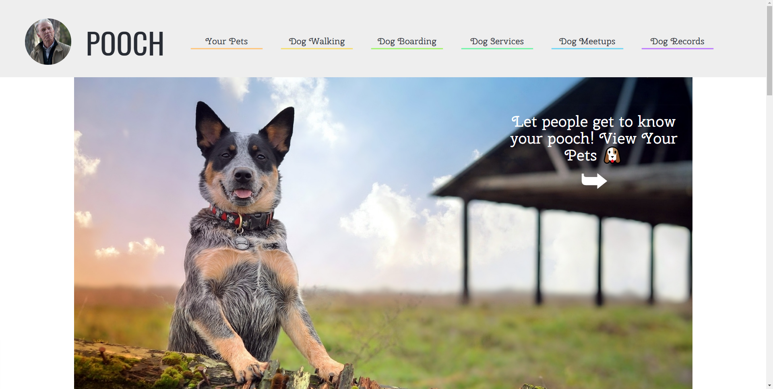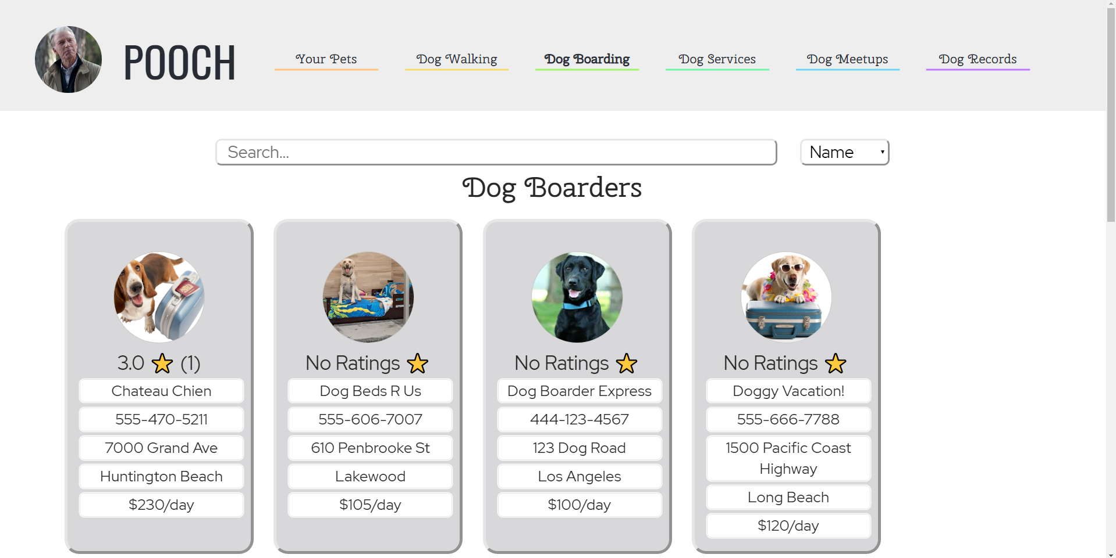

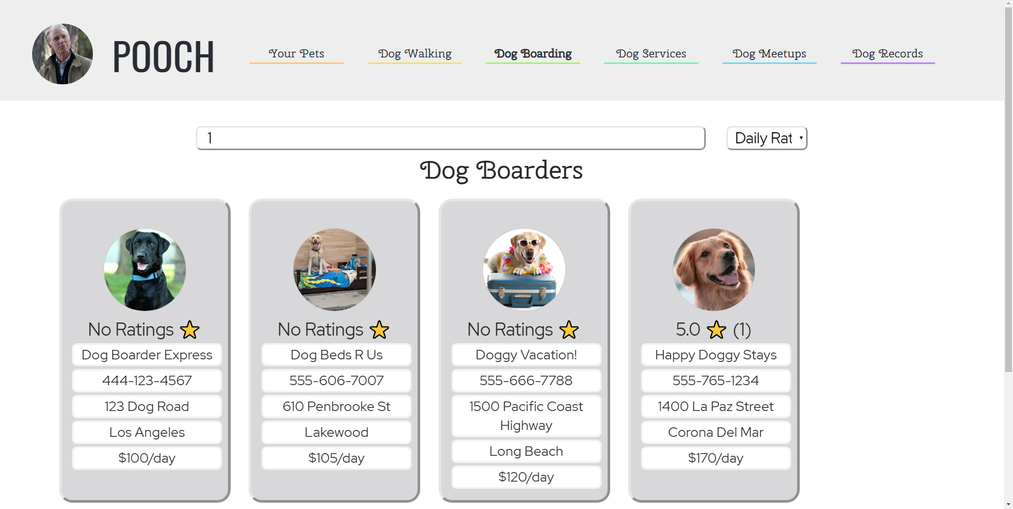

1. Review Dog Boarders
   1. Click on “Dog Walking” on the navbar
   2. Click on a tile
   3. Click on the empty stars on the right to set your rating
   4. Type in your review
   5. Click on “Submit Review”

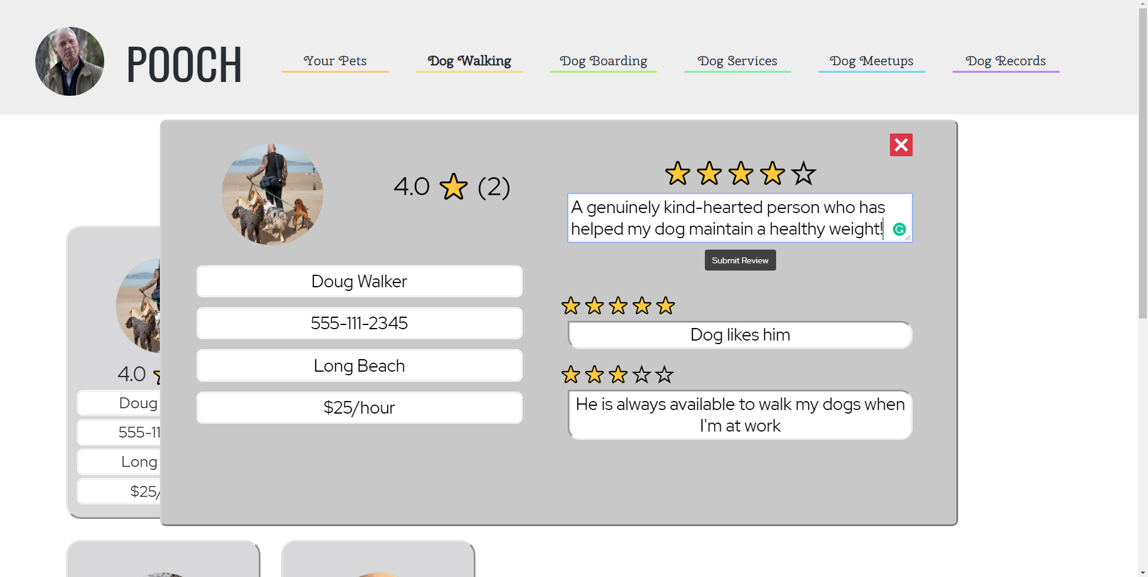

1. Search Dog Boarders
   1. Click on “Dog Boarding” on the navbar
   2. Click on “Search…” in the middle of the screen
   3. Begin typing for the dog boarders to be filtered, letter by letter (Note: the category to the right of the search bar determines what is being search for)



1. Sort Dog Boarders
   1. Click on “Dog Boarding” on the navbar
   2. Click on the dropdown menu that says “Name” by default
   3. Click on “Name”, “Address”, “City”, or “Daily Rate” to order dog boarders by that attribute

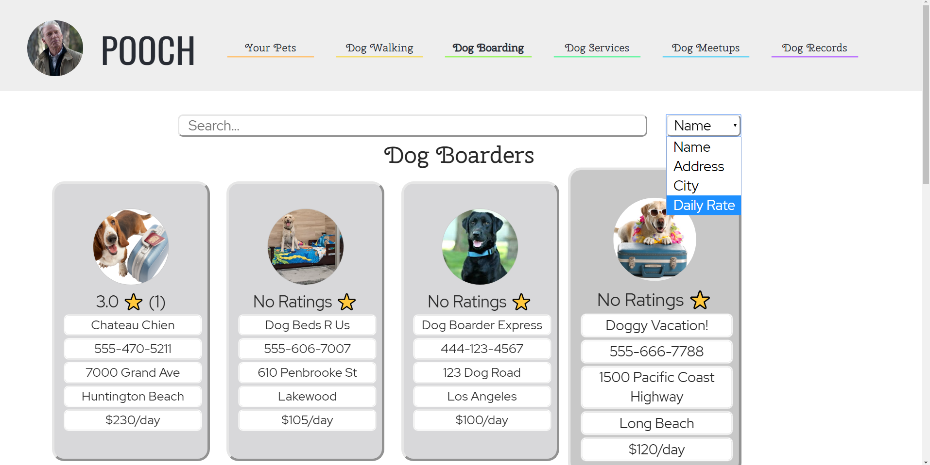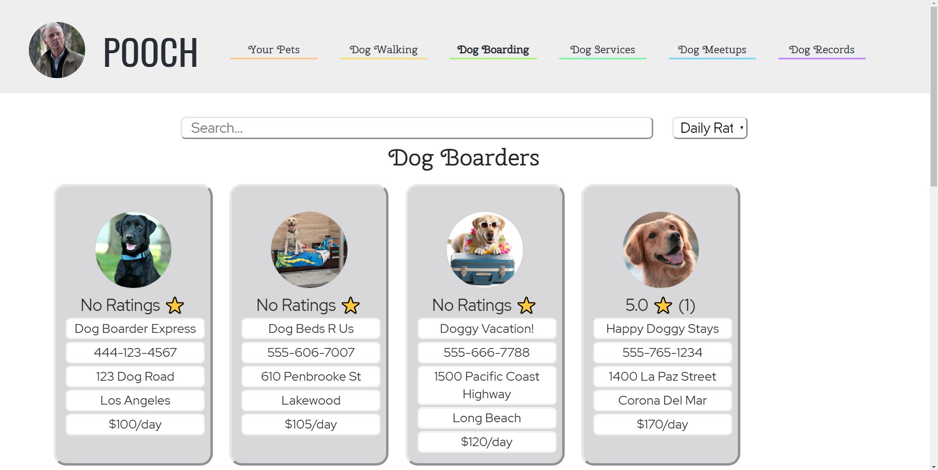

1. View Dog Boarders
   1. Click on “Dog Boarding” on the navbar
   2. Click on a tile
   3. See the boarder’s information, average rating, and reviews

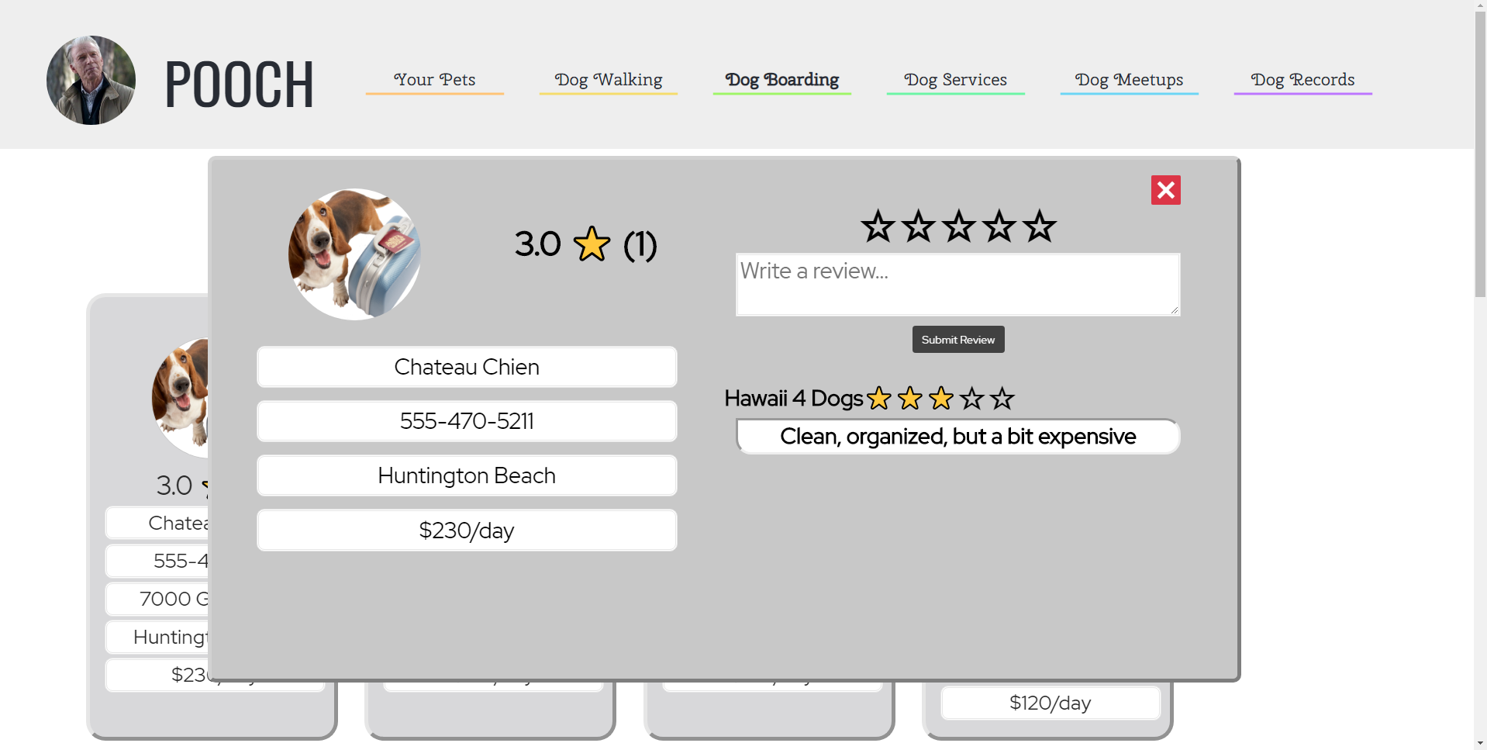

**Dog Services**

In the future, users will be able to view nearby pet supply stores, pet grooming services, adoption centers, and vets.

1. Search for Dog Services
   1. Click on “Dog Services” on the navbar
   2. Click on “Search…” in the middle of the screen
   3. Type in a dog service e.g. dog grooming, vet, etc.
   4. Click on the “Search” button
   5. Results will be shown based on the city listed in your profile

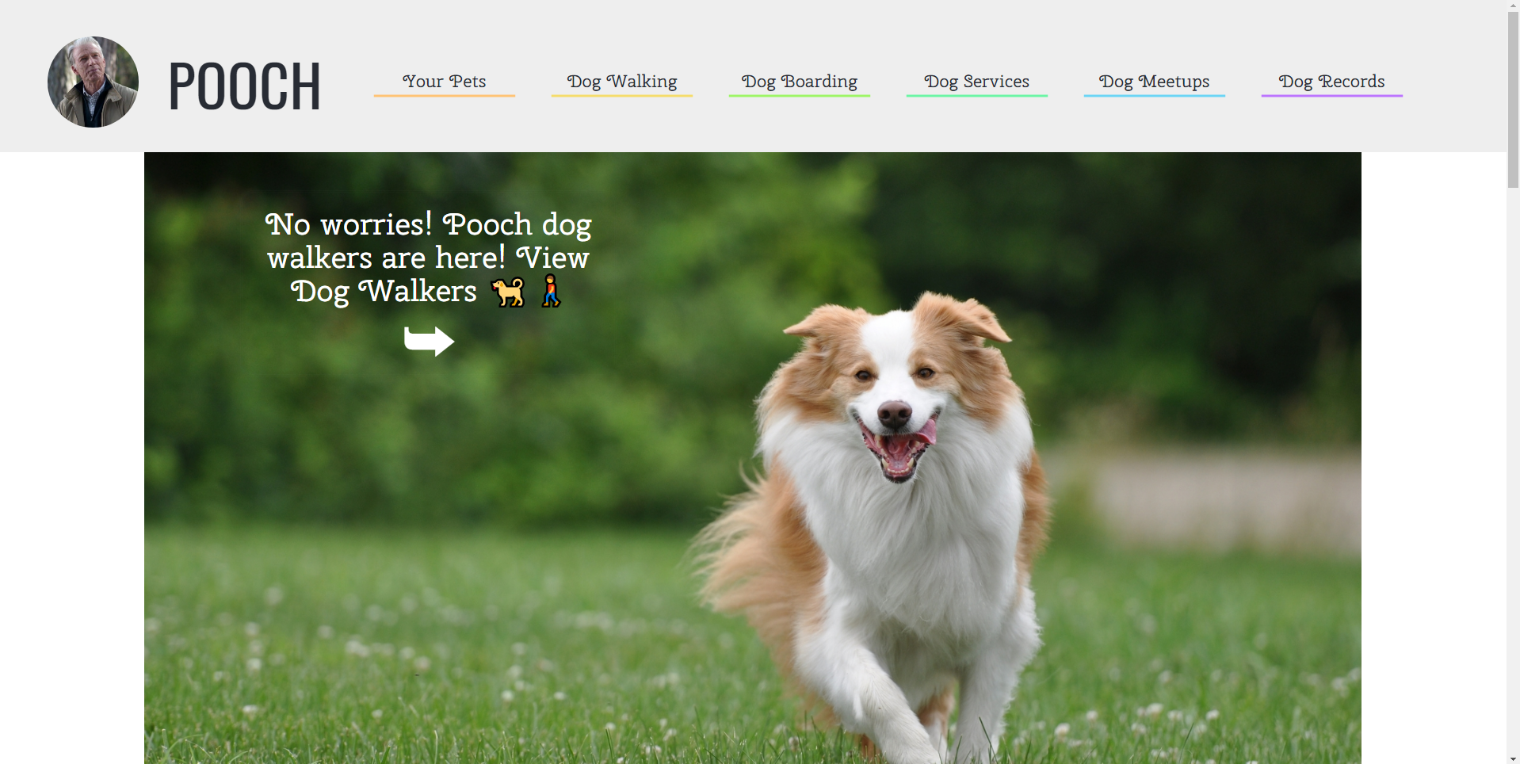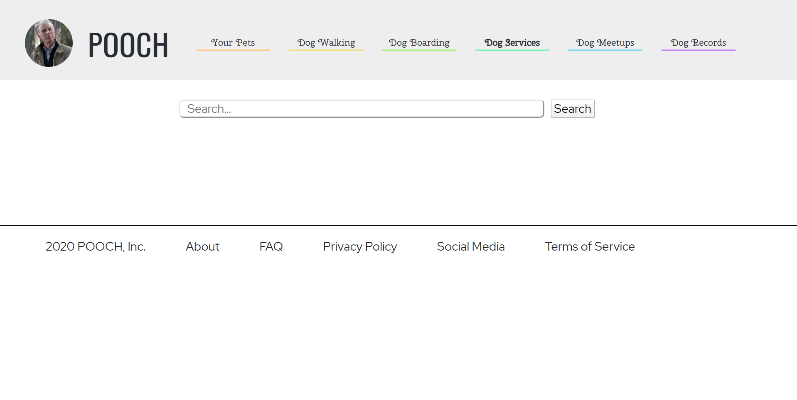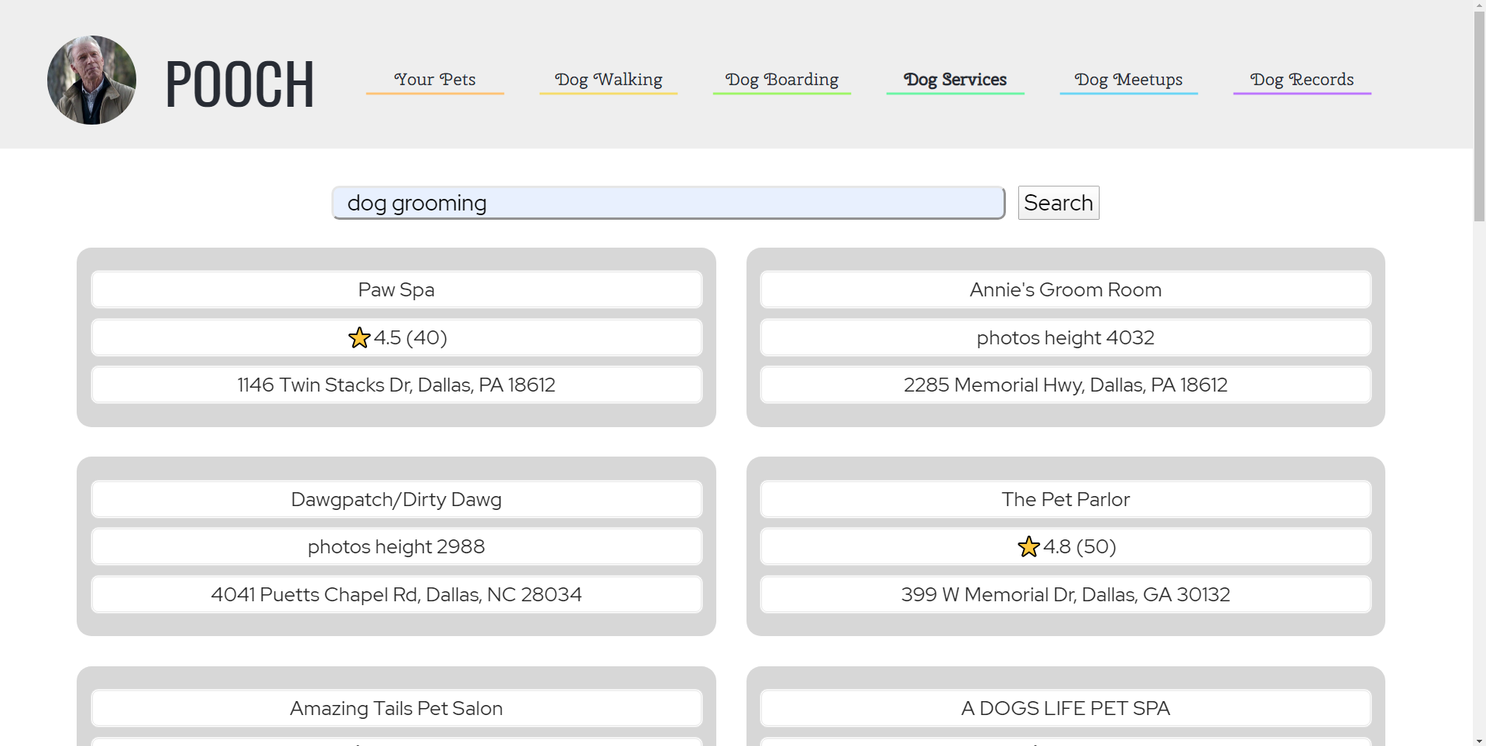

**Dog Meetup**

Users can schedule meetups at parks to let other dog owners know their pets will be looking for friends to play with. Users can also view meetups scheduled by other users. All the fields need to be filled in order to submit the form while scheduling a meetup or a pop up would be generated regarding the error in the input field. In the future, only meetups nearby will be displayed. Clicking on the meetup in the table will allow users to see additional information such as pictures.

1. Search Meetups
   1. Click on “Dog Meetups” on the navbar
   2. Click on “Search…”
   3. Begin typing for the meetups to be filtered, letter by letter (Note: the category to the right of the search bar determines what is being search for)

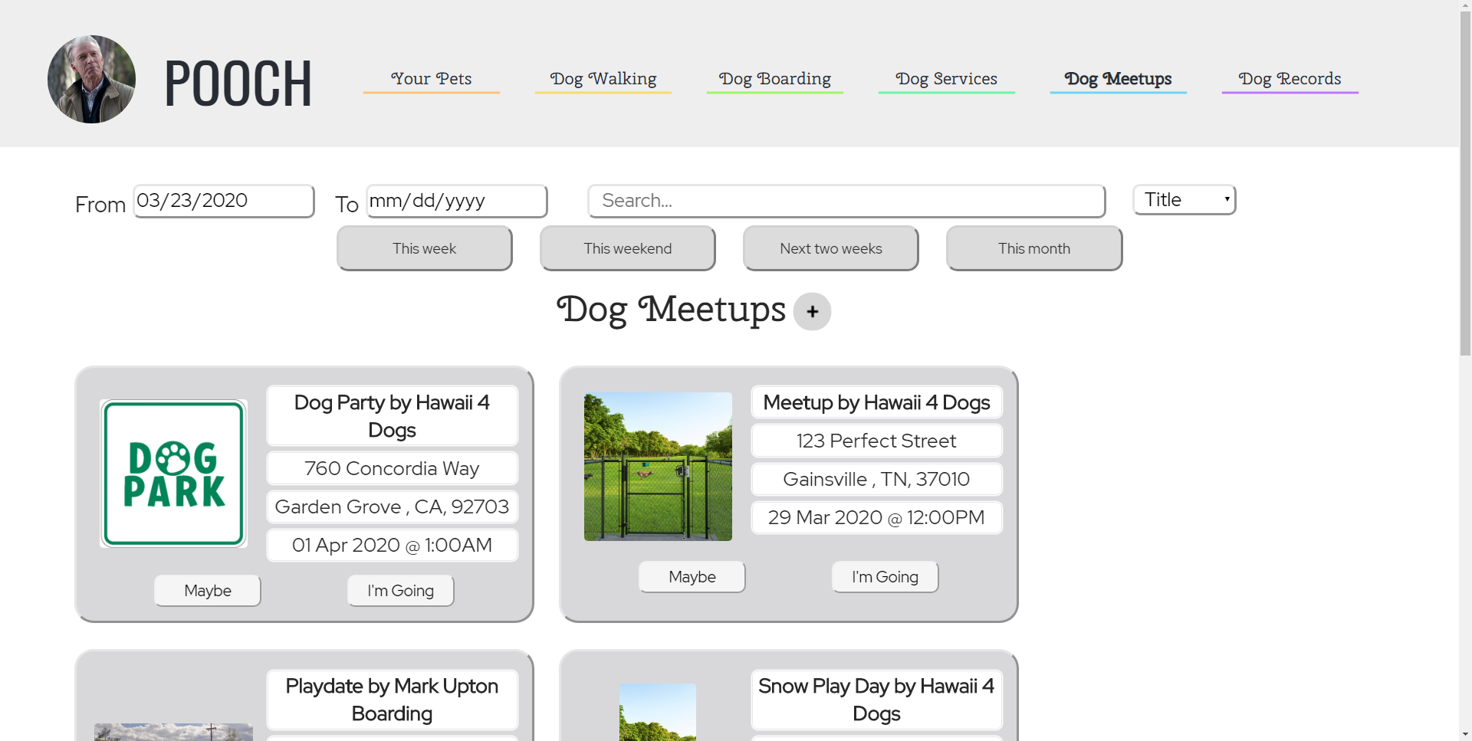

1. Sort Meetups
   1. Click on “Dog Meetups” on the navbar
   2. Click on the dropdown menu that says “Title” by default
   3. Click on “Title”, “Address”, “City”, or “Zipcode” to order meetups by that attribute
   4. Click on “This Week”, “This Weekend”, “Next Two Weeks”, or “This Month” to see meetups



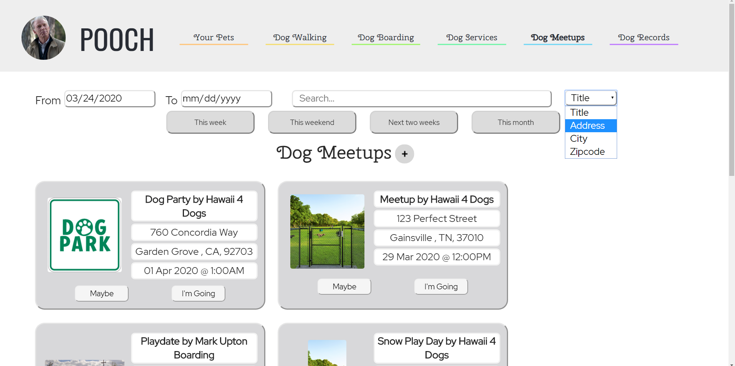

1. View Meetups
   1. Click on “Dog Meetups” on the navbar
   2. Scroll down to see the meetup



1. Create new meetup
   1. Click on “Dog Meetups” on the navbar
   2. Click on the plus button
   3. Fill out the form with your planned time and location
   4. Click “Submit Meetup” at the bottom of the form

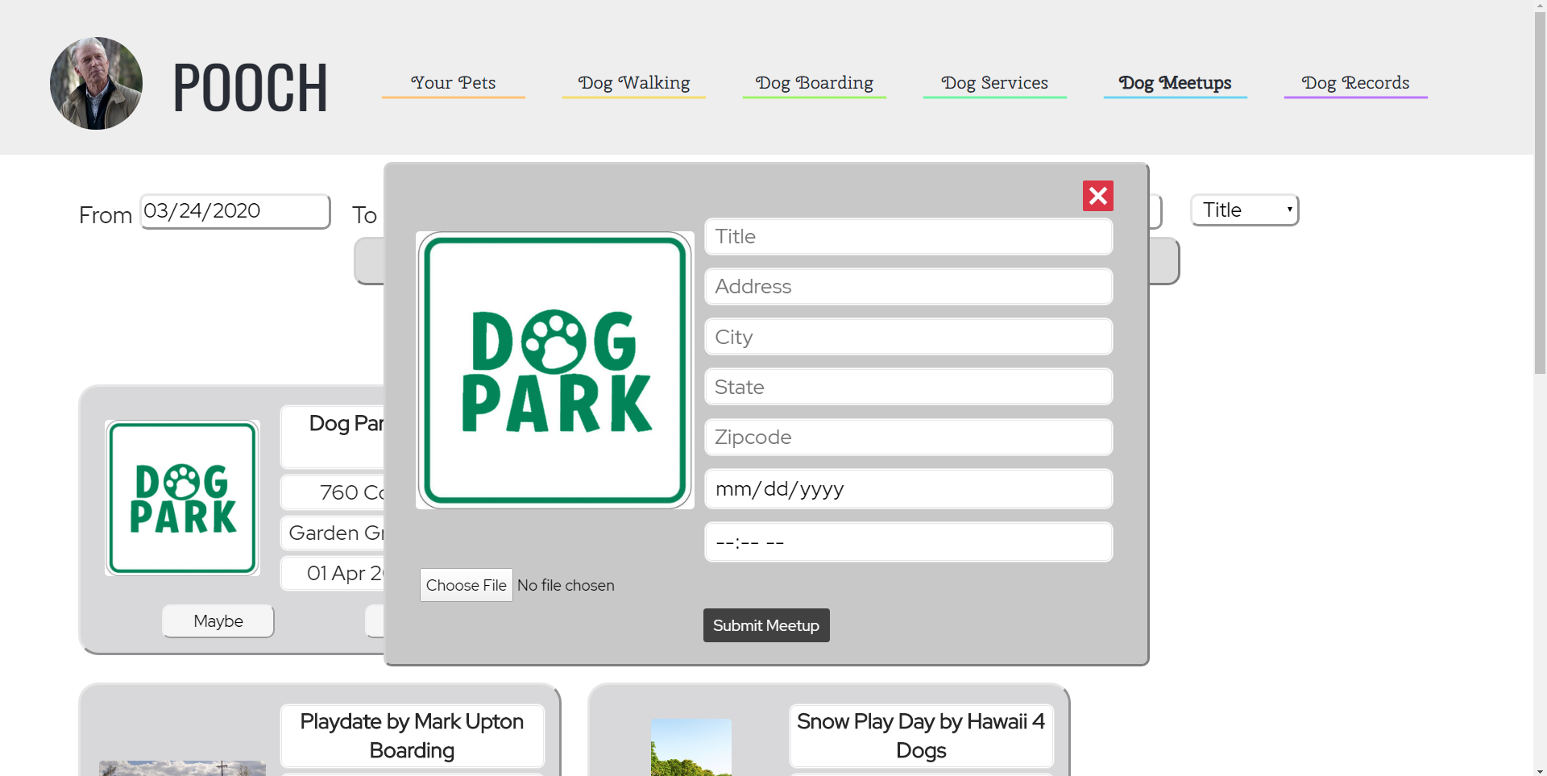

**Dog Records**

Users can click on the “add document” button to add the dog records. In the future, the button would be functional and users will be able to upload PDFs of their pet’s medical records to the website. Users will be able to access these files from anywhere, including on their phone while at the vet. This would be useful if a user forgets to bring an important document into the vet or if they have to take their pet into a new vet in a different city and don’t have their pet’s medical records easily accessible.

1. Upload Document
   1. Click on “Dog Records” on the navbar
   2. Click on “Choose File” in the middle and select the document in your computer you want to upload
   3. A preview of your document will be generated
   4. Click “Upload Dog Record” below the preview

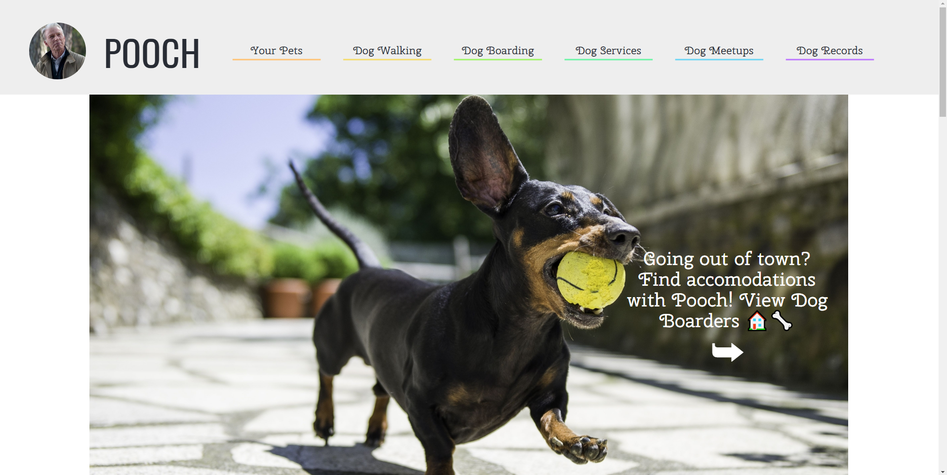

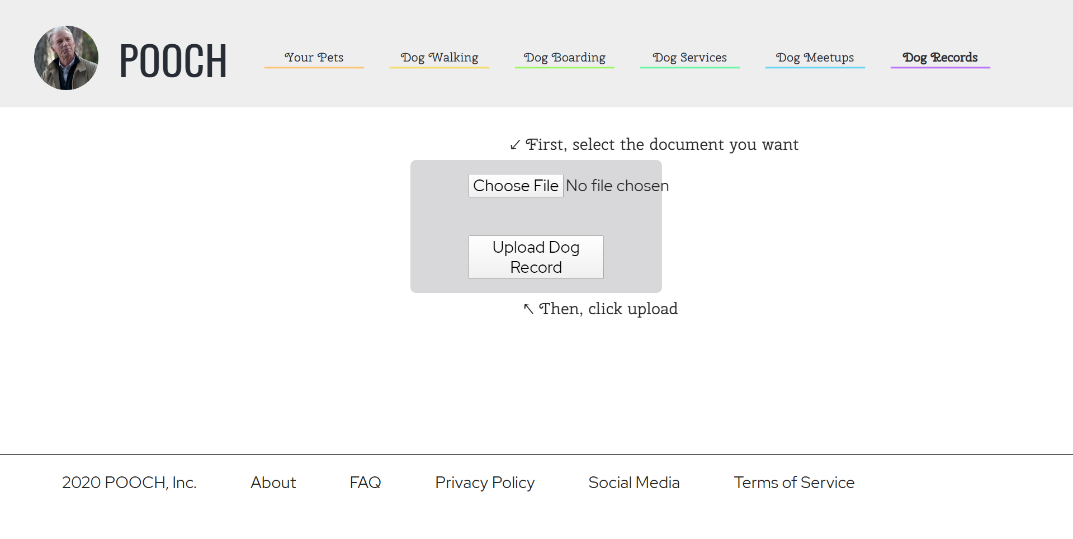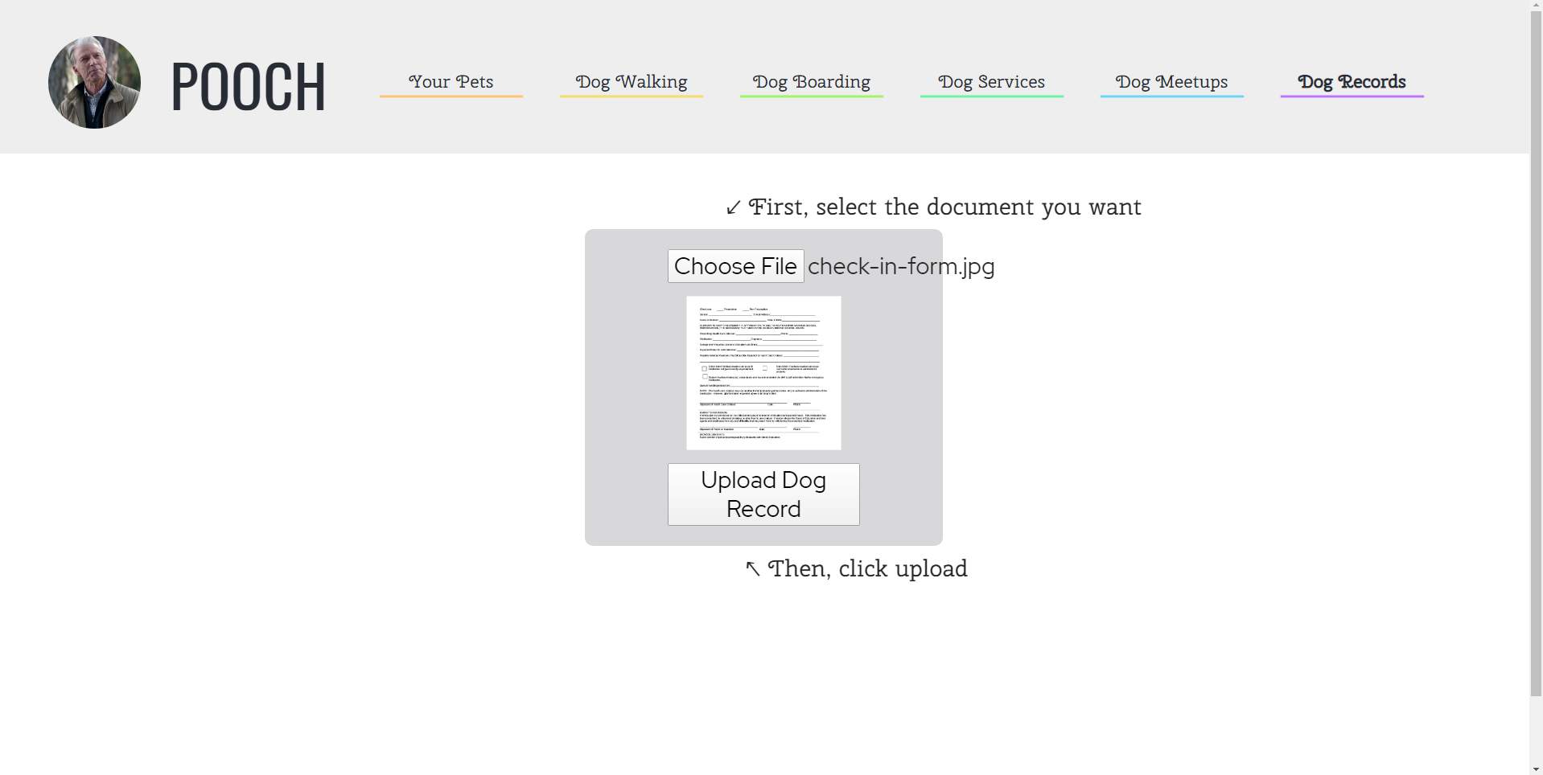

1. View Documents
   1. Click on “Dog Records” on the navbar
   2. Scroll down the page until you see small previews of your records
   3. Click on a document to view fullscreen

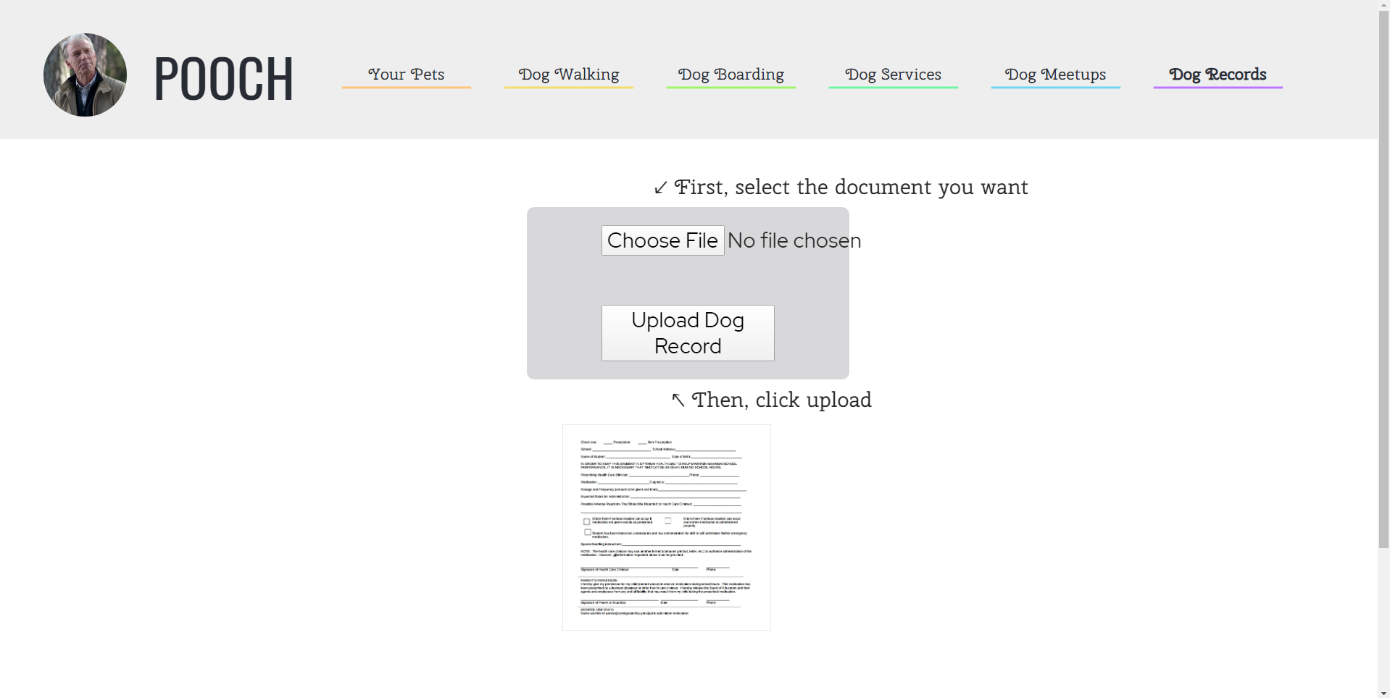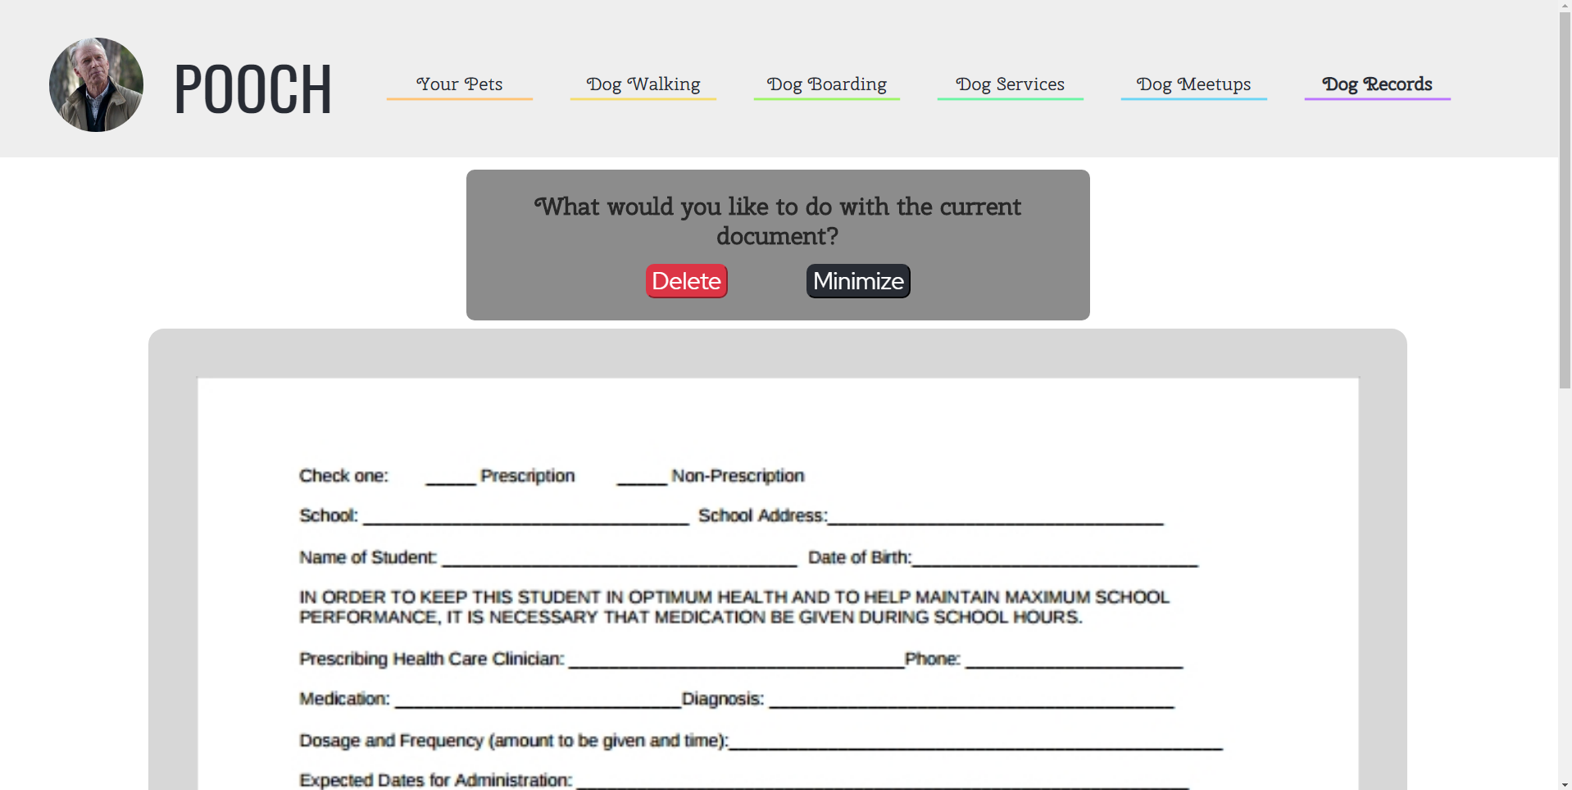

1. Delete Documents
   1. Click on “Dog Records” on the navbar
   2. Scroll down the page until you see small previews of your records
   3. Click on a document to view fullscreen
   4. Click on “Delete”



**Logout**

Users can log out by hovering over the profile picture on the navbar and clicking the logout button.

